**Normalization:**

A procedure which was invented by E. Codd For the purpose of maintain the data into a serialised and tabular format also known as relational data base.

The basic fundamental properties of normalisation of data is to maintain the data withing these limitations:

* No redundancy of data,
* No repetition of data,
* Data should be unique and one column with one data only.

Normalisation Anomaly:

Update, delete, insert

The normalisation process also includes normal forms server which is used to rectify the inconvenience and any unwanted problems to stay away from the database.

The most important feature of this database is the structure of it and the way data is organised.

E. Codd basically made the first invention of normalisation in the form of

**1NF (1 normal form)**

The data must be unique, single entry and no duplicate values

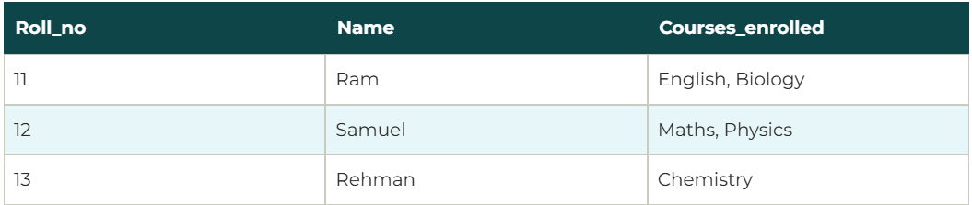

As the mentioned data above the course enrolled contains double values which means its not fulfilling the requirements of 1NF for this there would be generation of 2 tables one which roll no and name and another one with roll no with subjects one after another.

2Nf (2nd normal form)

This consist of the rules of 1st nf and the non key values should be depended on the primary key only and not other data

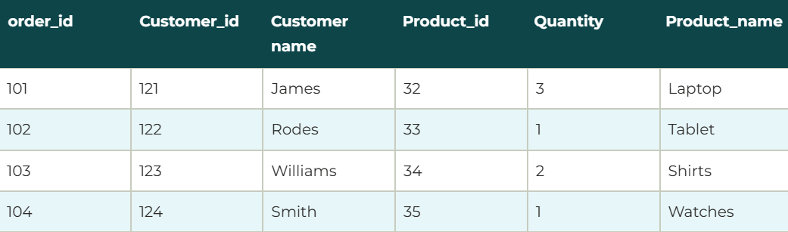

In this the order id , customer id, product id are the primary keys and customer name and product name are the the non key valus for them:

The customer id and customer name are interrelated and customer name is not going with any of the other columns which is against the rules so :

1st table will have order if, customer id, product id and quantity

2nd will have customer id and customer name,

3NF  
rules include 2nf and the non key column should depend on primary key and not on any other no key columns

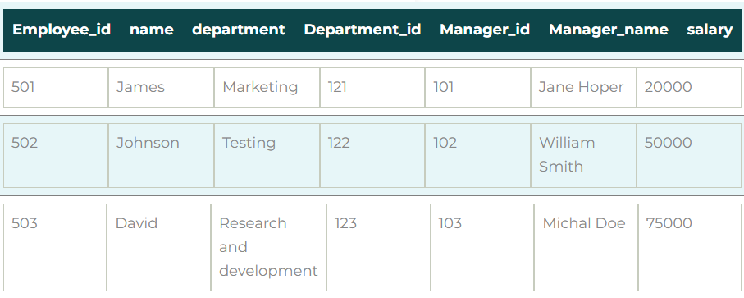

3NF is also called as Bcodds normal form

So in this case emp id, name and salary, deparment and department if and manager and manager id will be the small tables generated after normalization.

4NF

In 4 nf the rules of BCNF are applicable and also there is a rule of no value dependencies

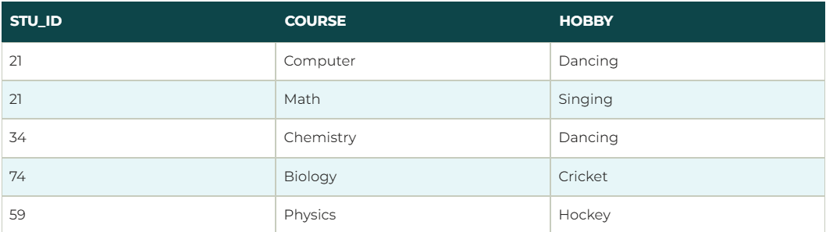

Here the course and hobby are the two independent identities which has no relation between them.

So there would be 2 tables generated 1: student id and course and student id and hobby.

5NF

5NF is also known as Project-join normal form (PJ/NF). And makes sure that there are as many small tables generated to reduce the redundancy and duplicity of data

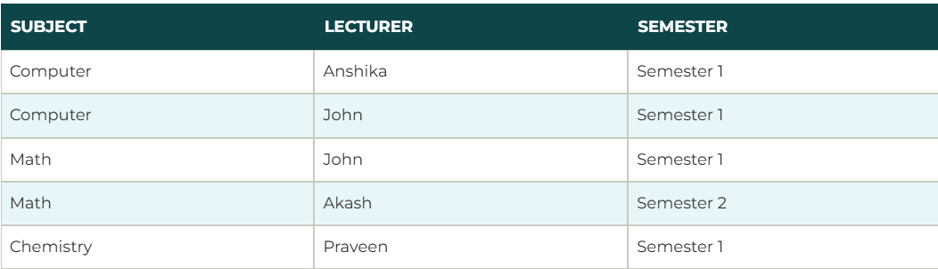

This is the last form of normalization and here there would be 3 tables generated for reducing the duplicate data of the tables and align them in structure format with maintain the data relation

Subject and lecturer, lecturer and semester and semester and subject respectively.

**Advantages and Disadvantages:**

* A more modest information base can be kept up as standardization disposes of the copy information. Generally speaking size of the information base is diminished thus.
* Better execution is guaranteed which can be connected to the above point. As information bases become lesser in size, the goes through the information turns out to be quicker and more limited in this way improving reaction time and speed.
* Narrower tables are conceivable as standardized tables will be tweaked and will have lesser segments which considers more information records per page.

**Disadvantages :**

* More tables to join as by spreading out information into more tables, the need to join table’s increments and the undertaking turns out to be more dreary. The information base gets more enthusiastically to acknowledge too.
* Tables will contain codes as opposed to genuine information as the rehashed information will be put away as lines of codes instead of the genuine information. Thusly, there is consistently a need to go to the query table.
* Data model turns out to be incredibly hard to question against as the information model is advanced for applications, not for impromptu questioning. (Impromptu question is an inquiry that can’t be resolved before the issuance of the question. It comprises of a SQL that is developed progressively and is typically built by work area cordial question devices.). Subsequently it is difficult to display the information base without understanding what the client wants.